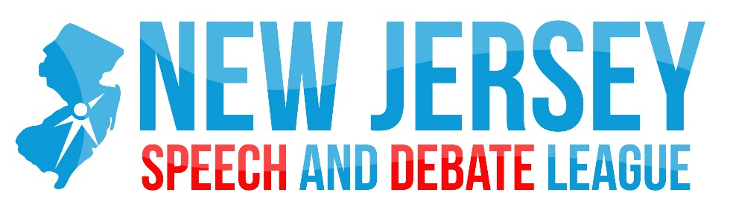

2016-2017 MIDDLE SCHOOL SCHEDULE

Date | Location | Events | Notes
Nov 4 | Montville | PF, Prose, Poetry, Impromptu, Improvisational Acting, Declamation  Judge Shadowing/Training | Public Forum debaters will be using the Sept/Oct topic:  Resolved: In United States public schools, the probable cause standard ought to apply to searches of students.
Dec TBA | Randolph | ALL | Tentative on a Friday
Jan 20 | Montville | PF, Prose, Poetry, Impromptu, Improvisational Acting, Declamation | Public Forum debaters will be using the January topic.
Apr 21 | Montville | PF, Prose, Poetry, Impromptu, Improvisational Acting, Declamation | Public Forum topic: TBD
May 5 | Ridge | ALL
May 12 | Randolph | ALL
May 19 | Long Valley | ALL

